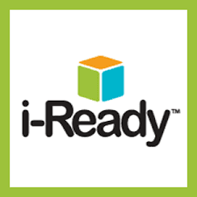

**Student and Family**

**i-Ready Access and Support from Home**

*i*‑*Ready* online lessons provide students with lessons based on their individual skill level and needs, so your child can learn at a pace that is just right for them. These lessons are fun and interactive to keep your child engaged as they learn. Your student's teacher can also assign lessons that are related to skills they are covering in their teaching and help reinforce what students are learning in class.

If your child has already taken the *i*‑*Ready Diagnostic* at school, an individual learning path has been created for them. If your child is new to *i-Ready*, their teacher will assign lessons based on grade-level lessons, and individual student needs. Students will also have access to Math Learning Games for fluency practice.

i-Ready is accessible on computers and iPads. iReady is not yet compatible with Android tablets or phones.

1. **Login to Clever:**
   1. [https://clever.com/in/columbuscity](http://clever.com/in/columbuscity)
   2. Enter your CCS Username: CCS Student ID number and CCS domain
      1. Example: [123456@columbus.k12.oh.us](mailto:123456@columbus.k12.oh.us)
   3. Enter your CCS Password: Student birth date with dashes
      1. Example: mm-dd-yyyy 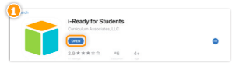
2. **Accessing i-Ready from an iPad:**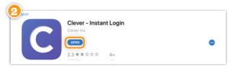
   1. Download *“i-Ready for Students”* from the App Store.
   2. Download “*Clever”* from the App Store.
      1. Clever may ask you to search for your school.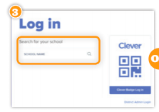
   3. Login with your CCS Username and Password
      1. Username: CCS Student ID number and CCS domain (Example: [123456@columbus.k12.oh.us](mailto:123456@columbus.k12.oh.us))
      2. Password: Student birth date with dashes (Example: mm-dd-yyyy)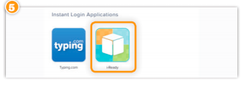
   4. Click the i-Ready icon.
3. **Reading Lessons and Math Lessons:**
   1. Your child will have access to both Reading lessons and Math lessons. (1)
   2. “My Path” lessons are assigned based on the results of your child’s diagnostic assessment. If your child is new to i-Ready, their lessons will be teacher assigned. (2)
   3. “Teacher Assigned” lessons are available to all students, but will only appear as a choice when the teacher has manually assigned lessons. (2)
   4. “Learning Games” are available to all students and help your child build math skills in fun ways. Your child will need to choose math at the top of the screen, and then select the Learning Games button in the bottom navigation bar. (3)

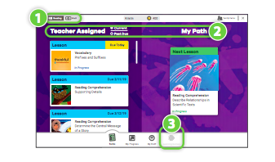

1. **How Can I Support My Child?**
   1. Make a plan for when they will complete their i-Ready lesson and for how long they will work in i-Ready each day.
   2. Encourage your child to take the lessons seriously and to try their best. Remind them to read the entire passage, use the tools available, and work out math problems on paper if they need to.
   3. Track their progress. Are they able to complete the lessons assigned by their teacher? How much time are they spending in their Online Learning Path if they have one? (This should be 45 minutes per week in addition to the lessons from the teacher.)Students should pass lessons with a 70% or higher score.
   4. Celebrate your child’s progress, such as passing a lesson or reaching a goal. Decide on a fun activity as a reward!
2. **For More Information and Support:**
   1. <https://www.curriculumassociates.com/supporting-students-away-from-school>
   2. i-Ready Family Center: <http://i-readycentral.com/familycenter/>
   3. i-Ready Technical Support: 800-225-0248
   4. Email Amber Bernal, [abernal8121@columbus.k12.oh.us](mailto:abernal8121@columbus.k12.oh.us)